THIS IS A PRACTICE ASSESSMENT. Show formulas, substitutions, answers (in spaces provided) and units!

A

B

25

6.75 m

The following question is about conservative forces.
1. A 15.0-kg box is pushed horizontally from A to B on a floor along the two paths shown. The coefficient of dynamic friction between the box and the floor is 0.375. Find the work done by friction over each of the two paths (use g = 9.78 ms⁻² ). Then state whether or not friction is a conservative force, and justify your statement. 1. hyp:______________
___________________________________________________________ legs:_____________

The following questions are about fields.
2. Why is the field view preferable to the action-at-a-distance view of forces? ____________________
__________________________________________________________________________________
__________________________________________________________________________________
__________________________________________________________________________________

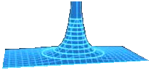
The following questions are about the set of equipotential surfaces shown to the right.
3. What physical quantity is the cause of the surface?
3. ______________

4. A negative charge is placed at the point X and released. Sketch in its path if it is free to respond to the surface. 4. __in picture____
X

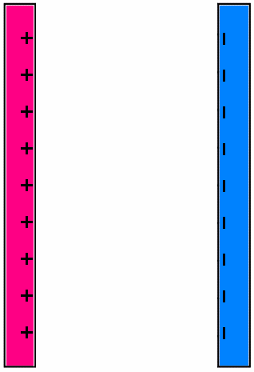
The following questions are about the parallel, oppositely-charged plates shown to the right.
5. Sketch in the electric field lines, both between the plates and at the edges.
5. ____in picture____

6. Justify that the electric field strength is constant between the plates by referring to your sketch. ____________________________________________
________________________________________________________________

7. Sketch in three equipotential surfaces (besides the two plates).
7. ____in picture____

8. If the potential difference between the two plates is 25 V, what is the potential difference between each adjacent pair of surfaces you sketched? 8. _________________

The following questions are about gravitational potential and the gravitational field.
9. Define gravitational potential difference. ________________________________________________
__________________________________________________________________________________
__________________________________________________________________________________
10. Sketch the pattern of gravitational field lines and equipotential surfaces surrounding a point mass.

10. ____in sketch____

11. Sketch the pattern of gravitational field lines and equipotential surfaces surrounding two point masses. 11. ____in sketch____

12. Use the definition of work (W = Fd cos θ) and the definition of gravitational potential difference (ΔV_{g} = W/m) to show that the gravitational field strength near the surface of Earth is g = -ΔV_{g} /Δh.

A 1.25-kg mass is moved from a point A in space having a gravitational potential of 0.0150 J kg⁻¹ to a point B in space having a gravitational potential of 0.0250 J kg⁻¹.
13. How much work was done by the gravitational force during that displacement?
13. ________________

14. Does it matter what path the mass followed in going from A to B? _____. Why? _________________
__________________________________________________________________________________

A charge of q = -15.0 μC is moved from point A, having a voltage (potential) of 6.75 V to point B, having a voltage (potential) of 8.25 V.
15. What is the potential difference undergone by the charge? 15. ________________

16. What is the work done in moving the charge from A to B? 16. ________________

17. Did the system gain, or lose energy during this movement? __________. Why? ________________
__________________________________________________________________________________

The following questions are about electrostatic potential and the electric field.
18. Sketch the electric field lines and the equipotential surfaces in the dipole to the right. 18. ___in sketch__
+

-

+

-

19. Draw the electric field lines between the flat conductor and the angled conductor. 19. ___in sketch__

20. Now sketch in the equipotential surfaces between the conductors. 20. ___in sketch__

